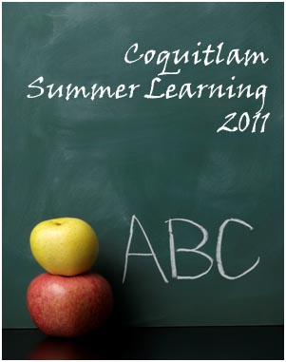
- Elementary Program
(Grades 1-5) July 12 – 29
Heritage Mountain, Parkland,
Pinetree Way
- Middle Program
(Grades 6-8) July 12 – 29
Scott Creek
- Academic Remedial & Skill Building Programs
(Grades 8-10) July 5 – 29
Charles Best

High School Credit Program
(Grades 10-12) July 5 – Aug 12
Centennial, Gleneagle, Coquitlam Open Learning
- Online Courses
- Face-to-Face Courses

For registration and contact information, please see us at www.summerlearningcoquitlam.ca

